**Engineering, Mathematics, and Computer Science Database**

**Adam Omundsen, Kelsey Knappenberger, Chris Voltz, Olivyah Vanek**

**Software Engineering - Fall 2022**

**Introduction:**

During the course Software Engineering Adam Omundsen, Chris Voltz, Kelsey Knappenberger, and Olivyah Vanek worked on a website for Stephanie Zegers the Industry Liasion for the School of Engineering, Math and Computer Science at Elizabethtown College. Stephanie requested a website that would help her keep all of her records organized. Thus, the Engineering, Mathematics, and Computer Science Database Flight Deck was created. There were four user stories created to help further explain the motivation for the website. Throughout the course of the semester there were many times the team was met with challenges they had to face. One challenge, which was the biggest challenge, was the creation of the data imports and exports section of the website. The Entity Relations Diagram was made and remade many times. In the end, there were many key features the team was able to finish. Those features were tested by giving another team in the Software Engineering course use cases.

**Purpose:**

As forementioned the Engineering, Mathematics, and Computer Science Database Flight Deck was created for Stephanie Zegers the Industry Liasion for the School of Engineering, Math and Computer Science at Elizabethtown College. Previously, she was using multiple applications to keep track of all of her data including: student and company records, her meetings with those same students and companies, and much more. We created this website so that Stephanie has somewhere to put all of her work and keep it all saved in one compact and convenient environment that only she has access to. This site also gives her a way to survey students about their experiences with the college.

**User Stories:**

**User:** Stephanie Zegers

**User Information:** ECMS Industry Liaison, Assistant Director of Engineering and STEM Development for Elizabethtown College

**Story:** One of the many roles of Stephanie Zegers is to meet with students within the School of Engineering, Math, and Computer Science at Elizabethtown College to help further their careers post-graduation. She forms partnerships with companies that are both from the area and all other regions, giving students options and more opportunity for growth after their academic career. Stephanie would like to be able to track both openings and internships within these corporations she has found in the past, and new ones she finds. Stephanie has meetings with students and during those meetings, she takes notes on the student to help find more specific jobs for that student, she also is able to see their resumes and gives them a survey that helps to narrow down her job search for these students. Currently, she is taking and storing these notes on Microsoft Lists and Microsoft Excel, but she wants somewhere that we can store all of this information together for her to be able to access one large database for all of her meetings. Making sure that the departments are split up and by concentration, not only by school. She wants to know how to enter and then tell the difference between student and company meetings. Also, be able to add meeting information/notes about both students and another section for companies. Be able to type in notes in all sections about meetings. Add job landings (post school/internships) rather than job openings.

**User:** Sara Atwood

**User Information:** Dean of School of Engineering, Math, and Computer Science at Elizabethtown College

**Story:** Potentially wants access to this information that is being collected by Stephanie on this database, so there will be a need for access by users other than Stephanie.

**User:** Registration and Records

**User Information:** Elizabethtown College Registration and Records

**Story:** Elizabethtown College’s Registration and Records can use this database to access student information about internships to be used for credits towards their graduation. Can be used in meetings for confirmation that they had an internship, or will be using an internship for credit. This will also be used to find jobs for students who are looking for work studies during the semester, and to help registration and records find if a student had done a work study in the past.

**User:** Alumni

**User Information:** Elizabethtown College Alumni

**Story:** Alumni could have access to this database to add in more job information from their companies and to give Stephanie access to more job options to present to students. Alumni will have the ability to access the database, but only to be able to submit more information about new jobs to Stephanie.

**User:** Student

**User Information:** Student at Elizabethtown College

**Story:** Students will have access to the database to be able to fill out their pre-meeting survey and provide Stephanie with needed information prior to the meeting, so Stephanie is able to prepare what is needed for their meeting.

**Analysis of the Key Problems**

While completing this website, there were a few key problems that were run into. One of the larger problems that was run into was the data import section of the website and this was due to the conversion formats that were used by Stephanie originally and how different these formats were compared to the layout that was being used for the website. Stephanie’s data was given to us in csv files, which we needed to import into our code. Also, the generalization of the website as a whole was difficult because the whole standard of the website needed to match and it was started in all different aspects, meaning not only the stylization was different, but also the languages it was coded in started out completely different because this project was started by many different groups within the class, rather than just one smaller group. So, everything that was originally started by the class as a whole, was different and this group had to work all of this information into the project and translate it to the language that we decided to use for the entire project.

**Designing the Data Model**

In order to create this data model, first there was a meeting with Stephanie Zegers to decide what data will be necessary and where within the site she wanted to put it. After an original data model was created, the team then met regularly with her and added as she was giving us information to add to the site. These regular meetings continued to give us more information and data that was necessary for the website and where within each data field this information belongs. We finalized the data model after a few meetings with Stephanie, with all of the correct data fields filled in and this finalized version of the ER model is shown below.

**ER Diagram**

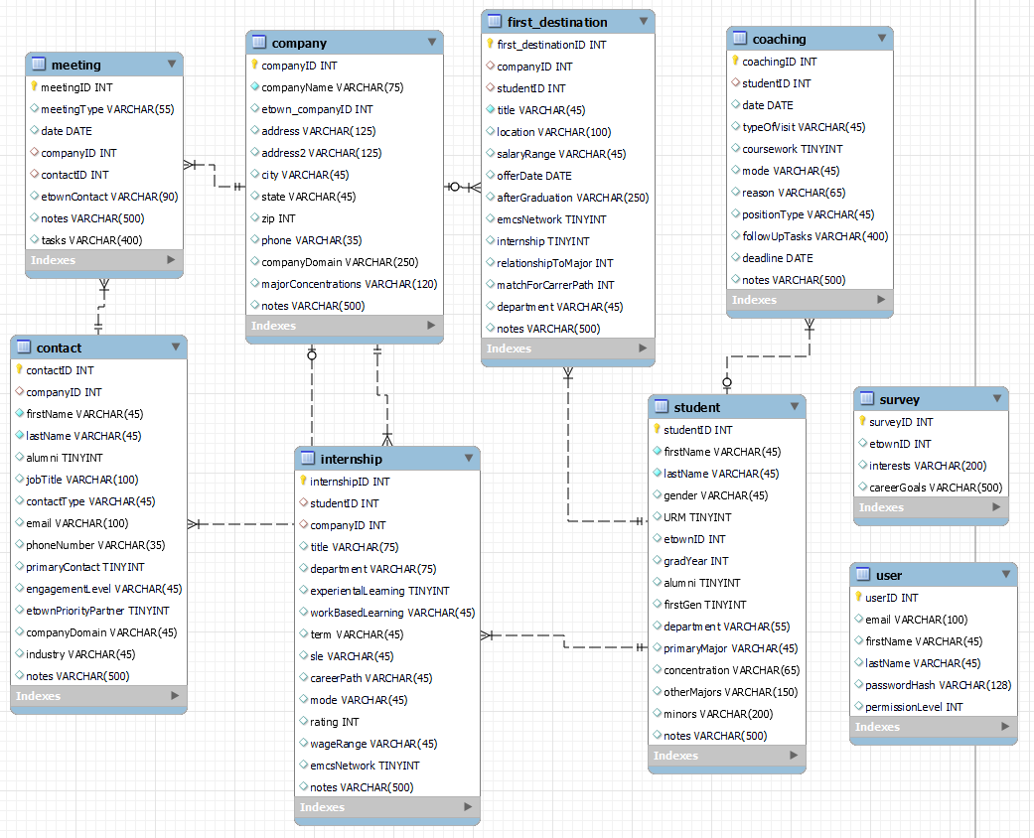

This ER Diagram above shows the finalized diagram that was used to create the actual website, which shows exactly what data fields are used for each item and where within the diagram they can be found.

**Division of Labor**

Adam: Wrote the back-end systems that interface with the database using php. Also wrote some javascript to create interactive pages for more complex user inputs.

Kelsey: Designed the main page of the website as well as the survey portion of the website

Chris: Designed the initial ERD model and helped design the layout for some of the pages.

Olivyah: Ensured that the website had a generalized look and that all documents were reached to completion, worked on overall design of all pages within the website, and helped button function.

**Discuss the Biggest Challenge**

The biggest challenge faced while creating this site is the data import because the data that was given to the team from Stephanie was given as csv files from her previous applications, so this had to be imported into the site, which was difficult, as the csv files are not directly compatible with the code being used for the website.

**Key Features:**

There are many key features that make this website function the way it does. This website has the ability to dynamically query the database and pull from the tables that we created using the data that was given to us by Stephanie. When using this website Stephanie will be able to display all of the data that she previously had stored within a csv file, search through the data, add data, edit data, and delete records when necessary. There is also a login and logout page, so that Stephanie is the only one able to access it with her login, keeping the data secure from others, as well as data import/export part of the site that imports and exports csv files onto this website. There is a section on the website where reports are created, which are generated based on data pulled from the database, and also a profile page allows for account management by Stephanie, meaning she is able to create and edit profiles for both students and companies that are added to the database. This code was written and commented on throughout, so that if there is a problem in the website when the creators of the website no longer attend Elizabethtown College, other students or faculty will be able to edit it and easily find where the issue takes place within the code.

**Testing Plan:**

We will meet with other groups and have them add profiles to the site to test and make sure that they work, along with testing foreign keys and making sure that they are able to import data into the site that are compatible. Also, when going through with testing the site, other students will be given “mock accounts” in which they are able to go through all of the features and ensure that they work and are styled how the site was originally planned by the creators.

**Use Cases:**

Stephanie Zegers will use this website in place of using the multiple applications she was previously using to track meetings with students currently in school and companies that are looking to hire, along with students post-grad.

| **Use Case UC-1: Login** | |
| --- | --- |
| **Related Requirements:** | REQ2.3 |
| **Initiating Actor:** | Stephanie Zegers |
| **Actor’s Goal:** | Log into site successfully with provided login information |
| **Participating Actors:** | Login page, database |
| **Preconditions:** | Provided login information stored in database |
| **Postconditions:** | User gets access to site, and then clicks logout button when done |
| **Flow of Events of Main Success Scenario:**  **1. Stephanie Zegers logs into site**  **2. Database reads in the correct login information**  **3. User granted access into site**  **4. Stephanie clicks throughout site and then logs out using “logout” button** | |

| **Use Case UC-2: Add, Delete, Edit Pages** | |
| --- | --- |
| **Related Requirements:** | REQ4, REQ5, REQ6, REQ7, REQ8, REQ9 |
| **Initiating Actor:** | Stephanie Zegers |
| **Actor’s Goal:** | Add, delete, edit the following pages: Blue Jays,Work-based learning Experiences, First Destinations, Coaching, Companies, Industry Contacts, and Meetings Pages. |
| **Participating Actors:** | Blue Jays,Work-based learning Experiences, First Destinations, Coaching, Companies, Industry Contacts, and Meetings Pages.  Database, generalizedfunctions.php |
| **Preconditions:** | Stephanie (user) creates mock data to add into site |
| **Postconditions:** | New users added, edited, and then deleted |
| **Flow of Events of Main Success Scenario:**  **Flow of Events of Main Success Scenario:**  **1. Stephanie Zegers adds data into each page**  **2. Stephanie Zegers edits data in each page**  **3. Stephanie Zegers deletes data from each page**  **4. Website ends up looking the same at the end as it did when started because all added data is deleted.** | |

| **Use Case UC-3: Data Export** | |
| --- | --- |
| **Related Requirements:** | REQ8, REQ9 |
| **Initiating Actor:** | Stephanie Zegers |
| **Actor’s Goal:** | Successfully export data from the site |
| **Participating Actors:** | Data export page, database |
| **Preconditions:** | Data needs to be added to Blue Jays page before an export occurs |
| **Postconditions:** | The data should match what is shown on the website after it is exported |
| **Flow of Events of Main Success Scenario:**  **Flow of Events of Main Success Scenario:**  **1. Stephanie Zegers adds data into the Blue Jays Page**  **2. Database reads in the data that was added to Blue Jays page**  **3. Data is exported using the Export Page**  **4. Data is downloaded to local machine and matches what is shown on Blue Jays page** | |

| **Use Case UC-4: Stylization** | |
| --- | --- |
| **Related Requirements:** | REQ1, REQ2, REQ3 |
| **Initiating Actor:** | Stephanie Zegers |
| **Actor’s Goal:** | Ensure all fonts, colors, and formats are the same throughout the entire site |
| **Participating Actors:** | All pages throughout the website |
| **Preconditions:** | Pages should all match with stylization, must be logged in to see pages |
| **Postconditions:** | All pages match throughout/none look different from each other |
| **Flow of Events of Main Success Scenario:**  **Flow of Events of Main Success Scenario:**  **1. Stephanie Zegers logs into site**  **2. All pages are checked to make sure they look the same**  **3. All pages match and overall stylization looks good** | |

**Traceability Matrix:**

| REQ | PW | UC1 UC2 UC3 UC4 |
| --- | --- | --- |
| REQ1  REQ2  REQ3  REQ4  REQ5  REQ6  REQ7  REQ8  REQ9 | 4  5  1  5  4  4  4  4  4 | X  X X  X  X  X  X  X  X X  X X |
| Max PW | 4 5 4 5 | |
| Total PW | 4 25 8 10 | |

**Conclusion:**

This website was created with the goal of giving Stephanie Zegers a convenient database that stores all of her old and new information for all of the students and companies she talks to frequently. This project had many obstacles the team had to jump over, but in the end the website was successfully completed with all of the working features that Stephanie wanted. Certain features that were completed at midway were approved by Stephanie and will be edited when needed.